Concur Expenses Process Workflow

Document Information
Version No | Status | Publish Date | Primary Contact | Comments
0.1 | Draft | - | Finance Controller

Approval
Company: |  | Process:
Prepared By: |  | Date:
Reviewed By: |  | Date:

Key Process Contacts
Region | Name | Job Title
China | Amy Shi | Senior Finance Manager
Hong Kong | Cindy Chiang | Accounting Manager - Accounts Payable
Macau | Mona Lok | Finance Manager

Table of Contents
1. Document Information 1
1.1 Approval 1
1.2 Key Process Contacts 1
3. Process Description 3
4. Purpose 3
4.1 Expense Report Initial Check – Handled by processor 3
4.2 Accountant Review 12
4.3 Processor Action 13
4.4 Payment list Generation (14th of each month) 14
4.5 Payment List Validation 15
4.6 GV File Upload - For HK only; China/Macau skip this step and proceed to next step 15
4.7 Email Notification 15
4.8 Journal Entry Generation (15th of each month) 16
4.9 Upload to JDE 16
Simplified Workflow Table 16
Concur Processor SOP 17
Appendix A - Flowchart 18

Process Description
Staff reimbursement for both Corporate Card expenses and out‑of‑pocket claims is managed through the Concur system. This process applies to all employees in Hong Kong, Macau, and Mainland China, ensuring consistent policy compliance and efficient expense handling across the region.
Employees are required to submit expense claims via Concur, attaching valid supporting documentation. Corporate Card charges should be reconciled in a timely manner, while out‑of‑pocket expenses must be entered and approved before reimbursement.

Purpose
This workflow ensures accurate expense processing, compliance with company policies, and timely posting to financial systems.

Expense Report Initial Check – Handled by processor
- Verify transaction date, expense type, payment method (Out-of-pocket / Company Paid), and amount based on the receipts uploaded by employees in Concur. Hardcopy invoices shall be retained in the local office: HK employees keep them by themselves; Macau & China Finance Team retains them for local summary validation.

Login to Concur and go to the home page, as shown in the figure

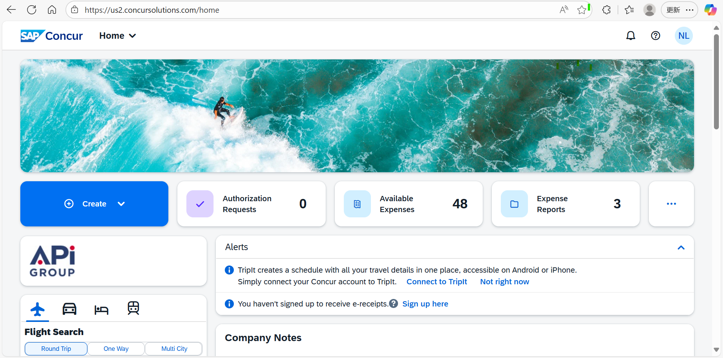

From the homepage, click Home, and then choose Expense.

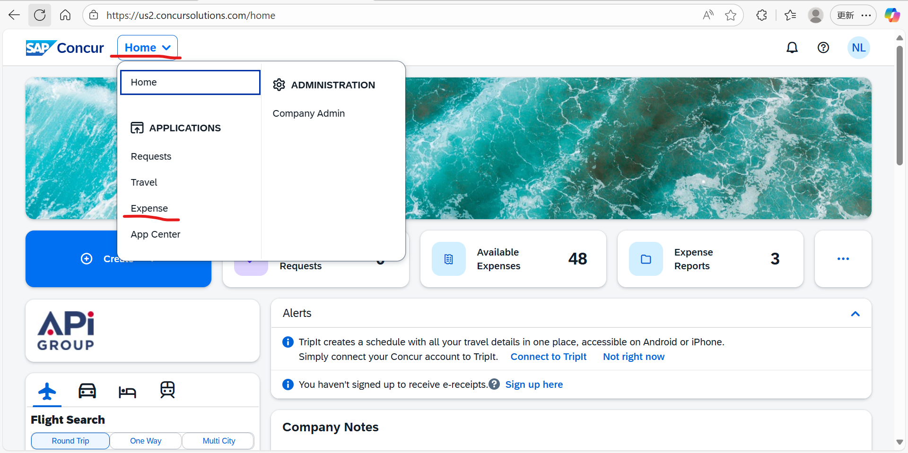

After entering the 'Expense' interface, click 'Process Reports'.

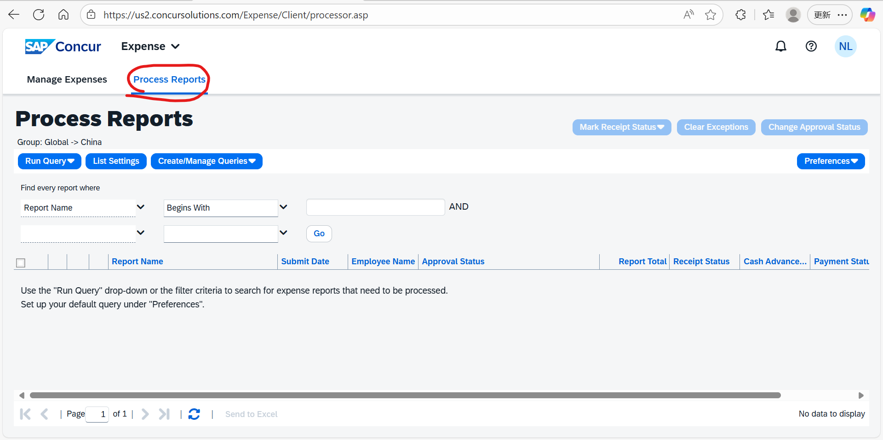

In “Process Reports,” click the “Run Query” button at the top left, and select “Reports Ready for Processing”.

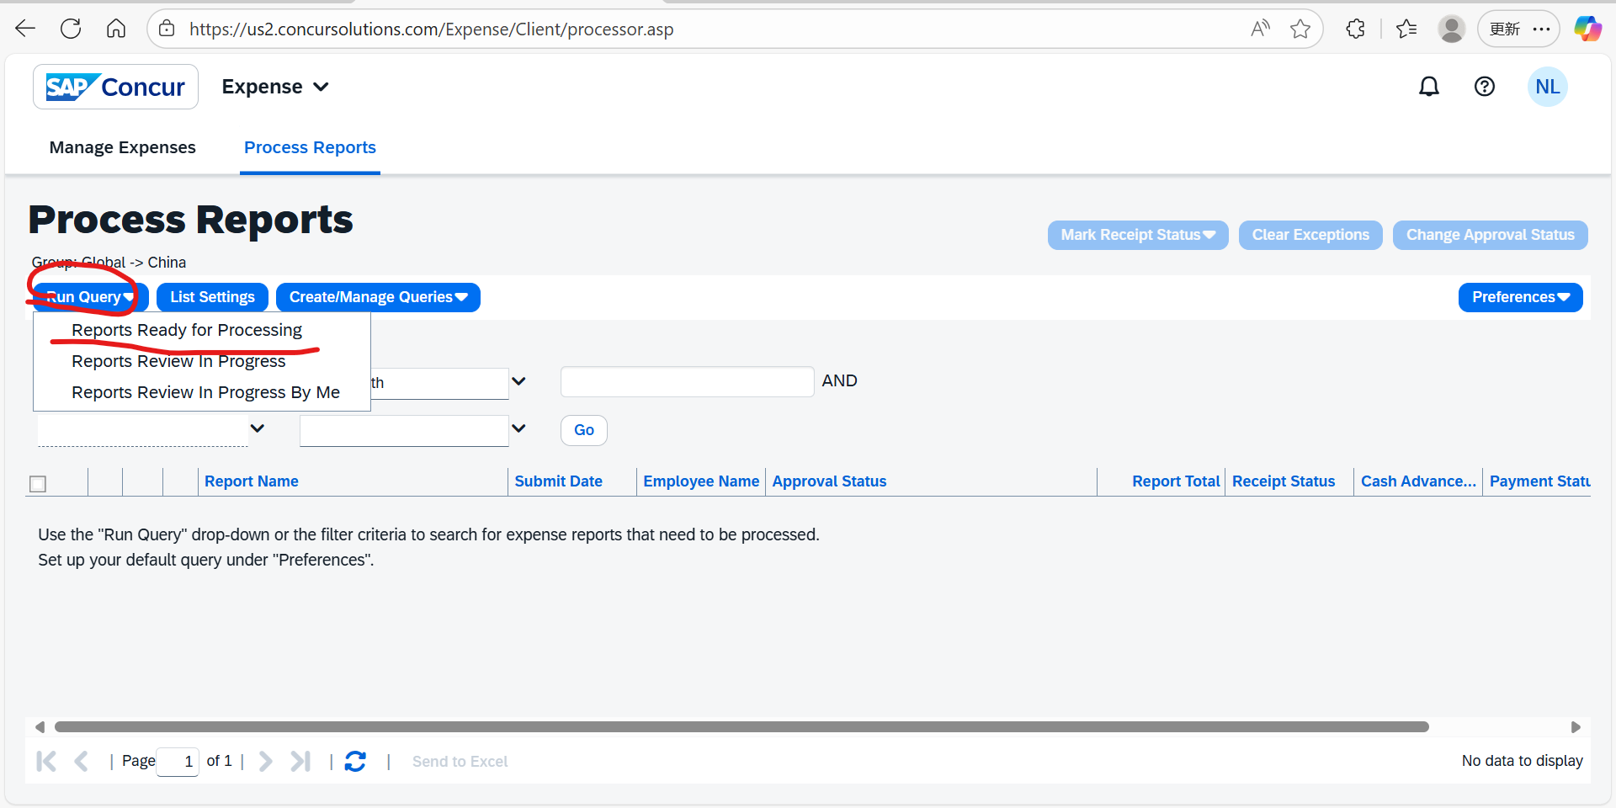

At this point, all Concur reports with an Approval Status of “Approved & in Accounting Review” will appear, indicating that the employee’s expense claim has already been approved by their direct manager and can proceed to the accounting review. If you need to export the list of all pending expense claims, select each report and then click “Send to Excel”.

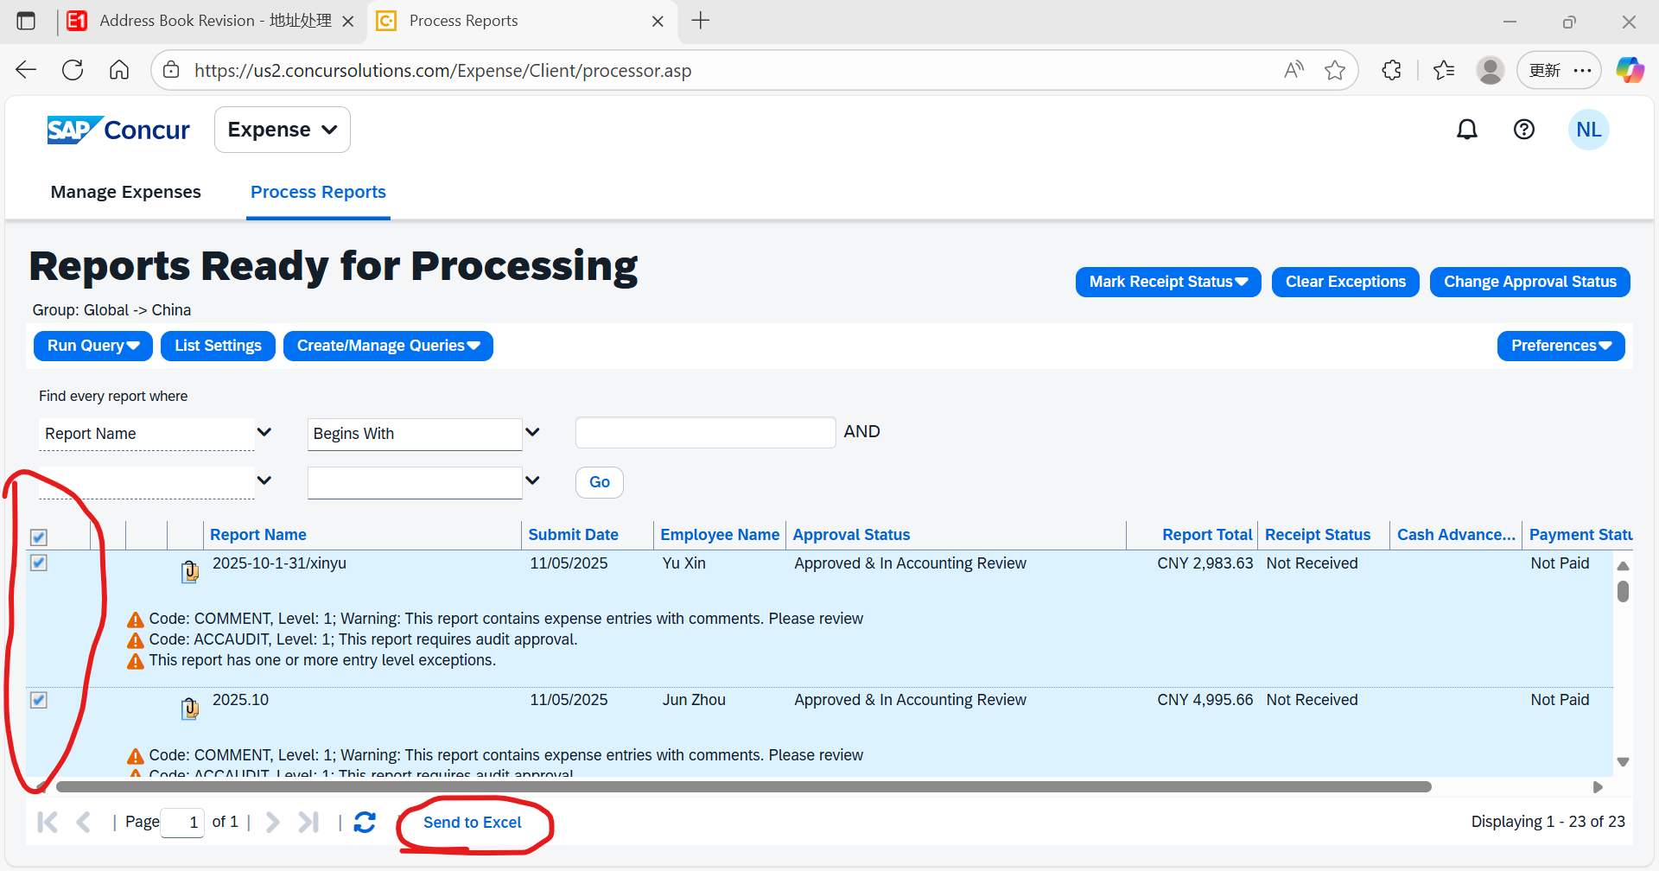

The list of pending expense claims will appear as shown in the figure below. Based on the “Report Name” in this list, we can search for each employee’s pending expense claim in the Concur system.

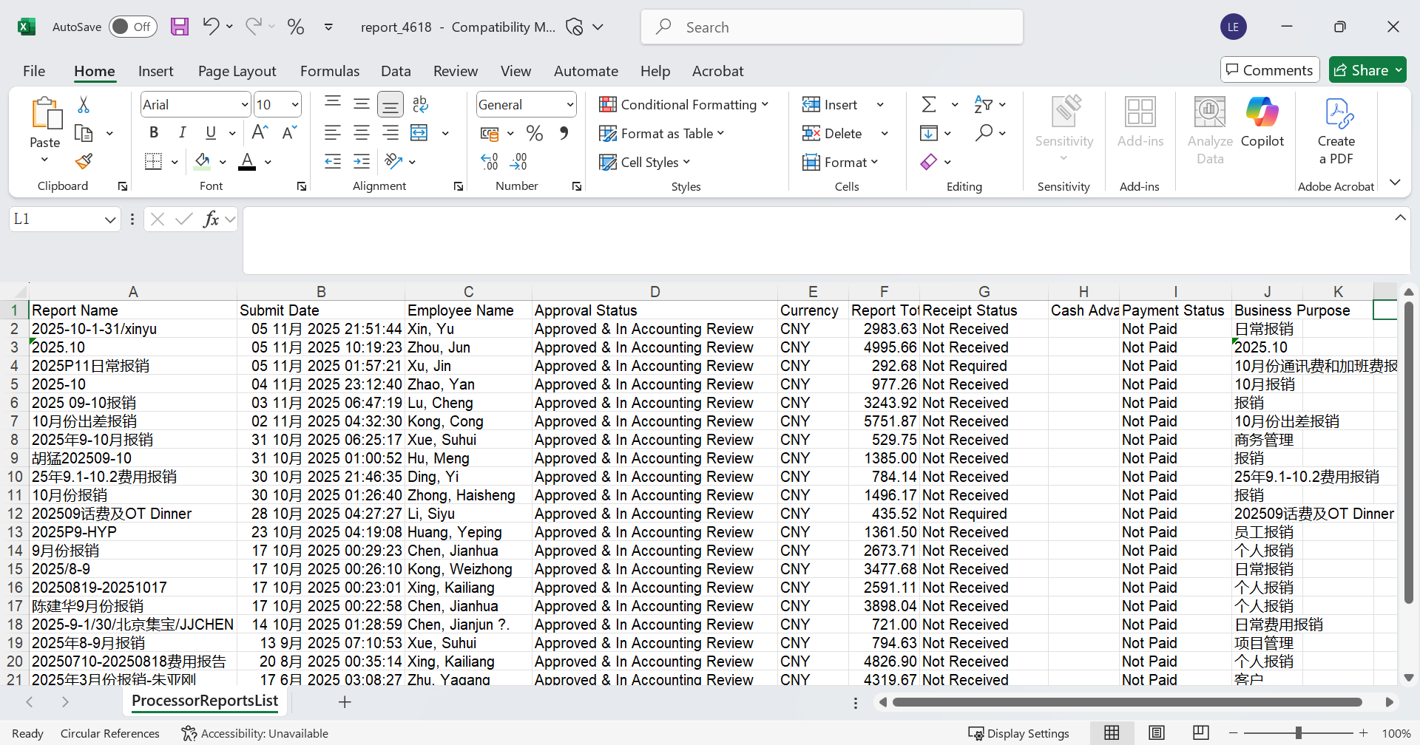

Use the expense claim marked in green as an example for searching, and copy its “Report Name.”

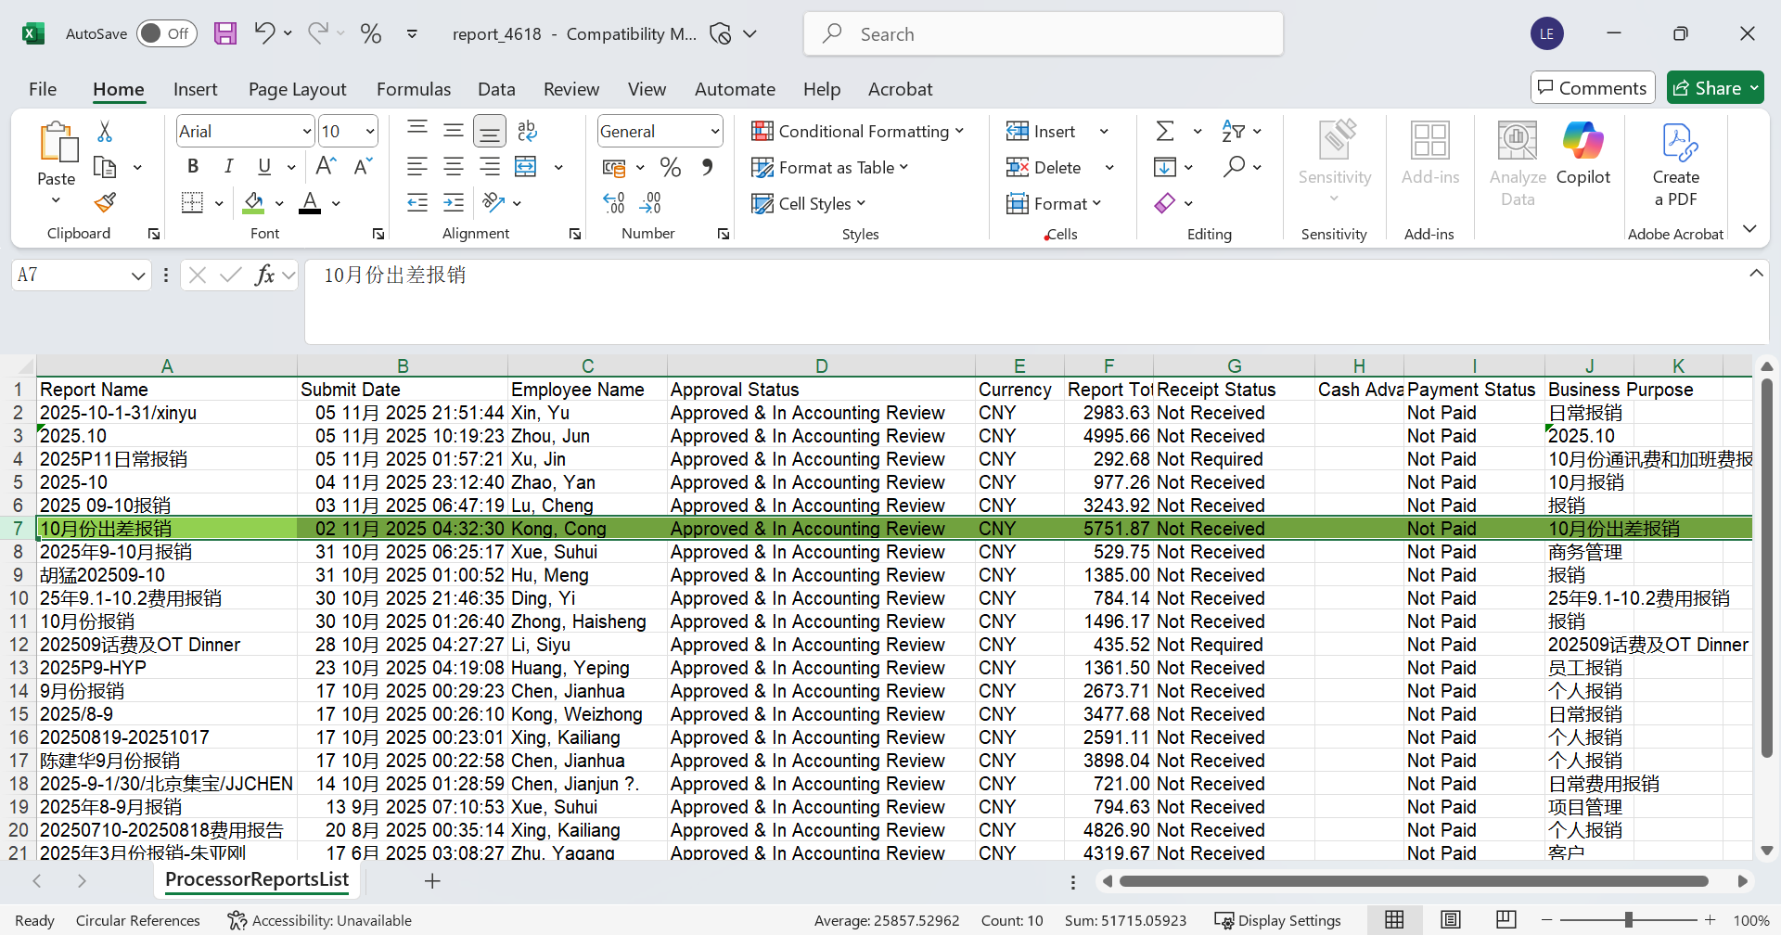

Return to the “Process Reports” page in Concur, select “Report Name” and “Equals” from the dropdown, enter the corresponding “Report Name,” and click “Go.” (You can also search using other criteria; the method is the same.)

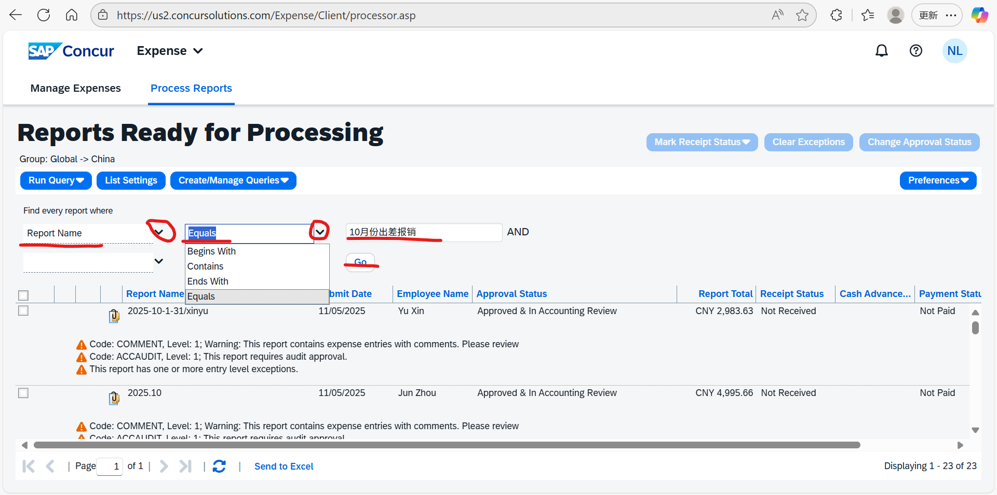

As shown in the figure, navigate to the corresponding employee expense record.

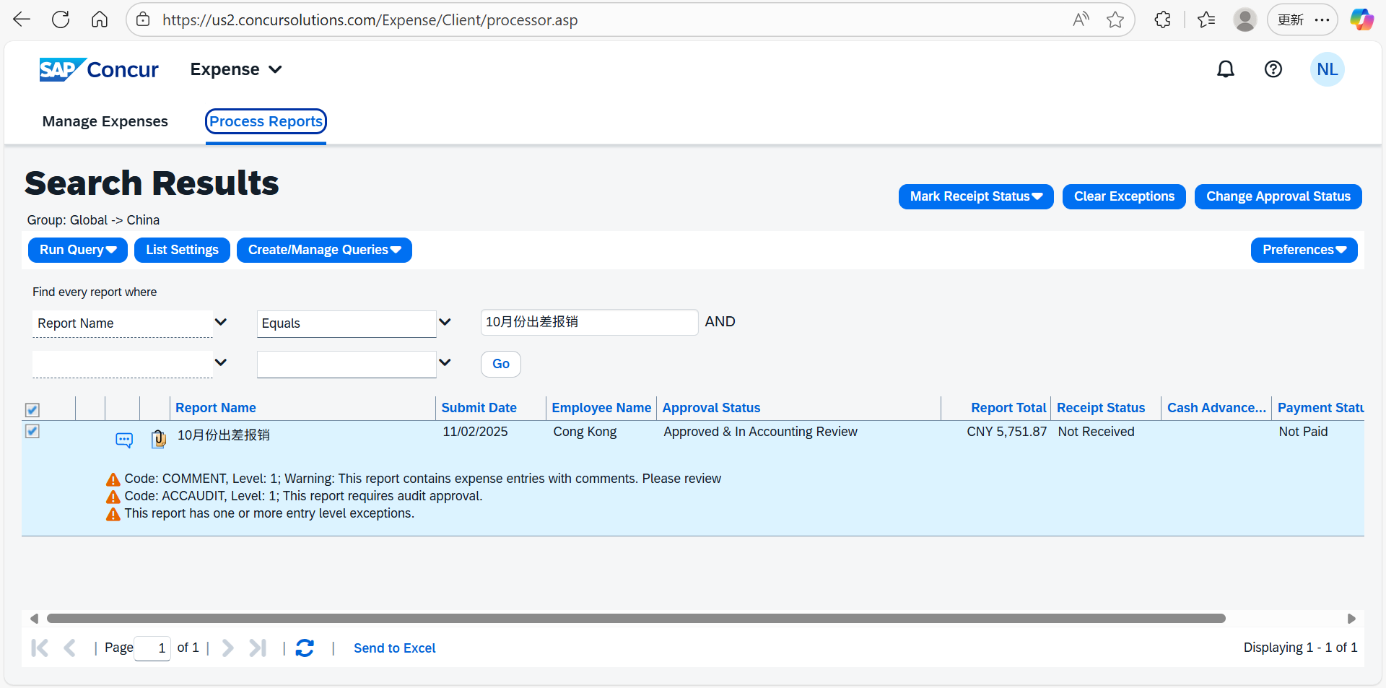

Double-click this employee expense claim to open the detailed expense page, as shown in the figure.

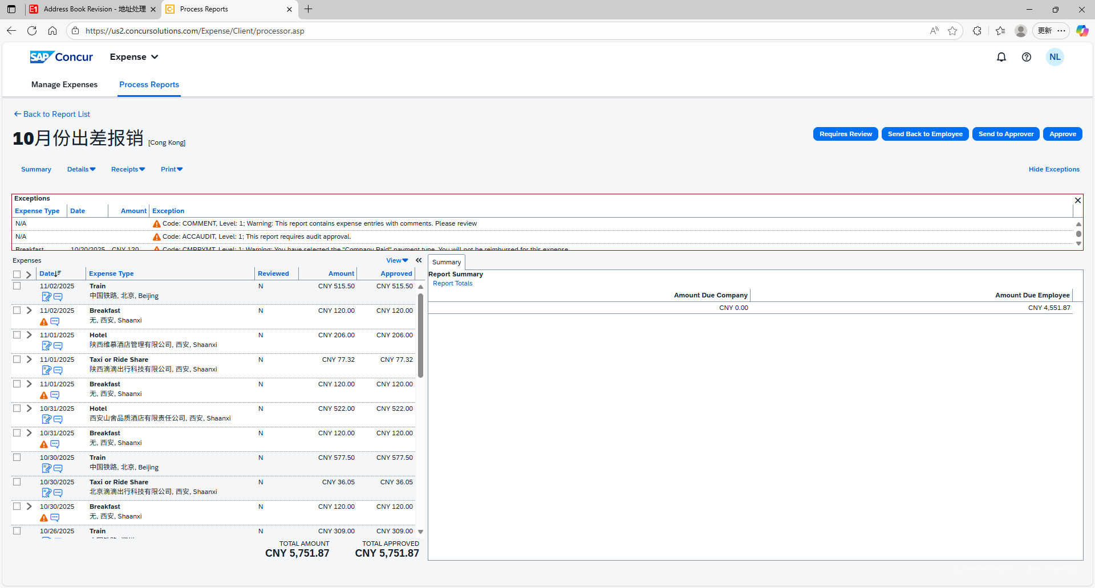

Select “Expense Type” to sort and group expenses of the same type.

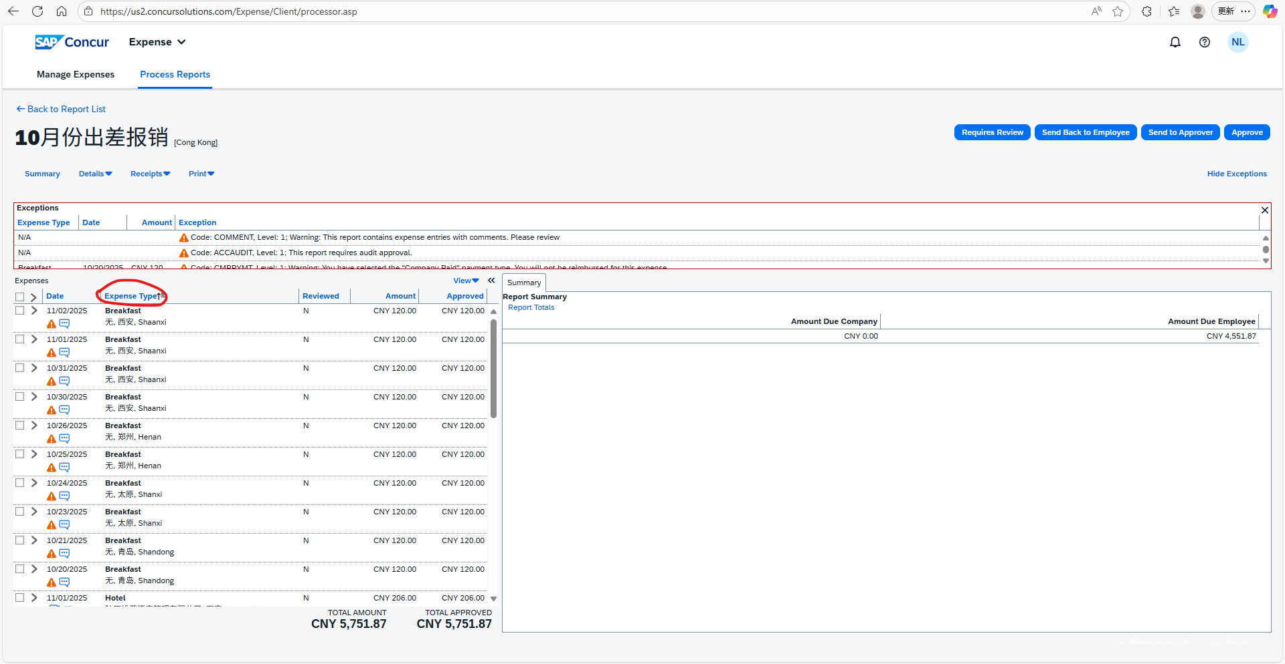

Some Key Check Points:
- For expenses such as business travel, business entertainment, training fees, or employee group activities that require pre-approval, check whether the approval emails are complete and whether the amount is within the pre-approved limit without overspending.
- Verify that the “Transaction Date” matches the actual date the expense occurred.
- Ensure the “Business Purpose” is specific.
- Confirm that the “Expense Type” is correct.
- Check whether project cost details are noted. For reimbursements by engineers/PMs, except for phone bills and expenses not involving a project number (such as pre-sales support or group activities), all other expenses must include a project number. Review the “Project/Job/IO” field; if missing, return for completion.
- Verify that the “Company Paid/Out of Pocket” option is accurate.

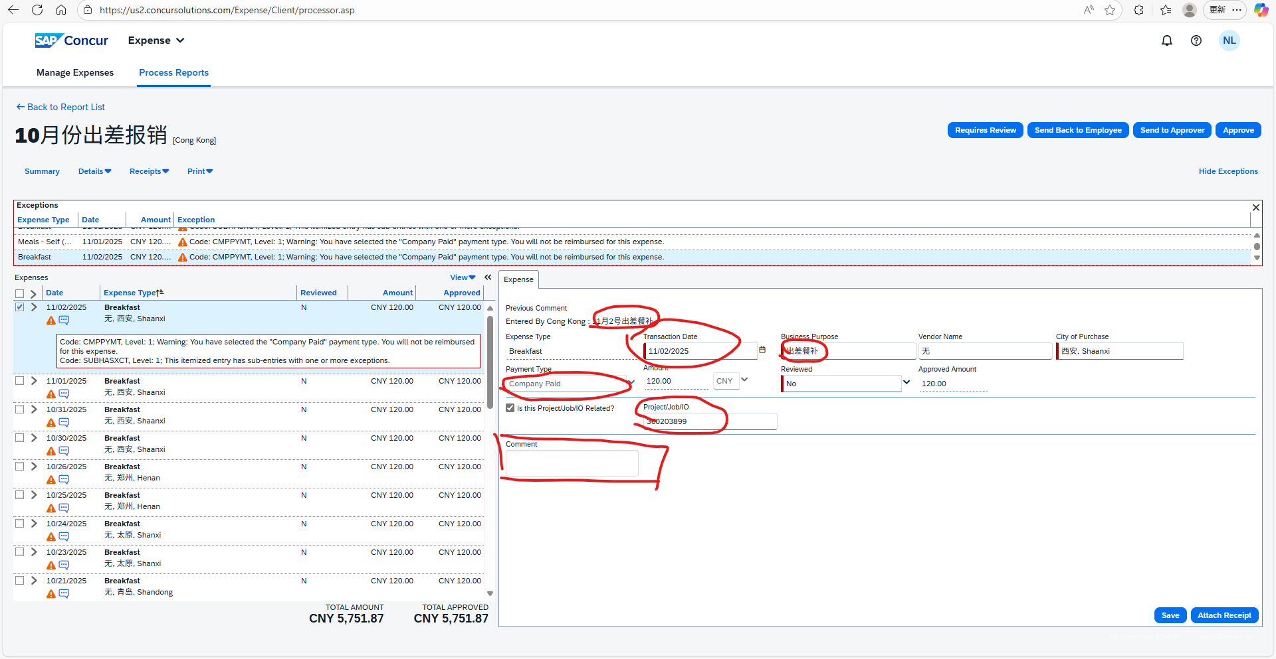

After checking the expenses, click “Receipt Image” on the right to review the attached invoices and pre-approval emails. For accommodation expenses, check the invoice and folio to ensure the invoice amount matches the claimed amount and that the invoice date is within the reimbursement period.

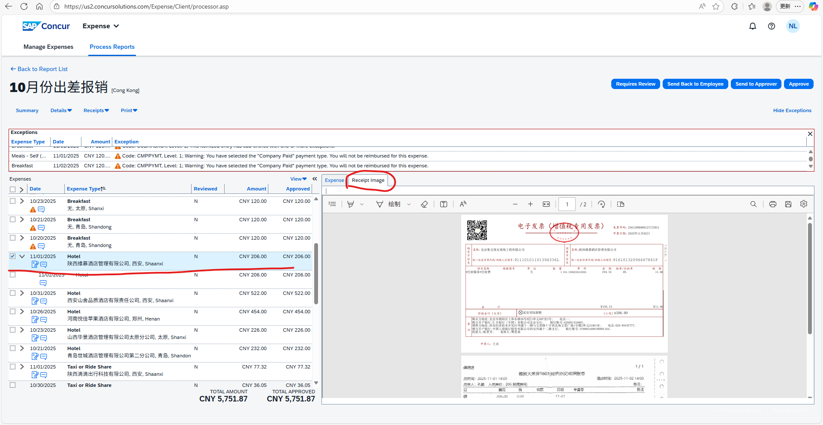

For the expense type “Third Party Entertainment,” check whether the list of “Attendees” is provided.

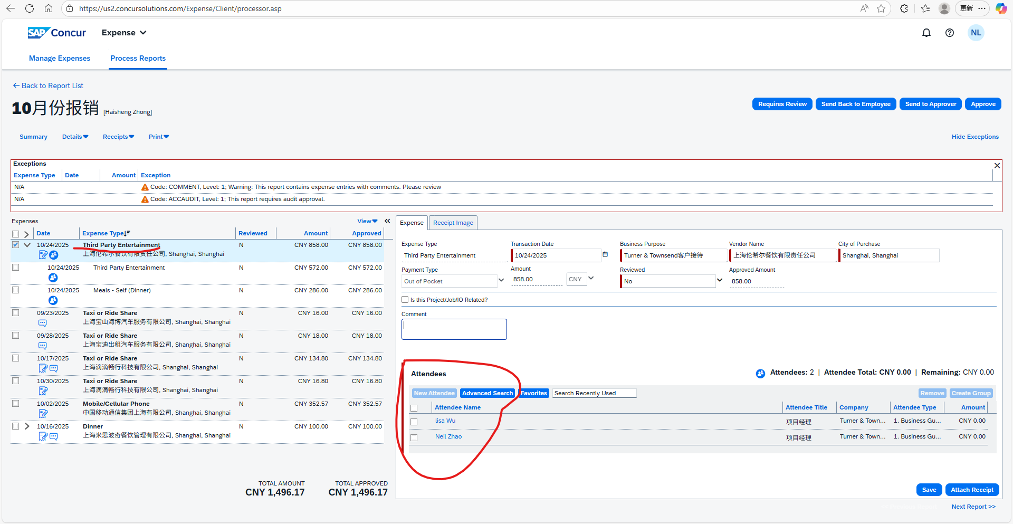

When the expense claim needs to be returned to the employee, click “Send back to Employee” at the top right.

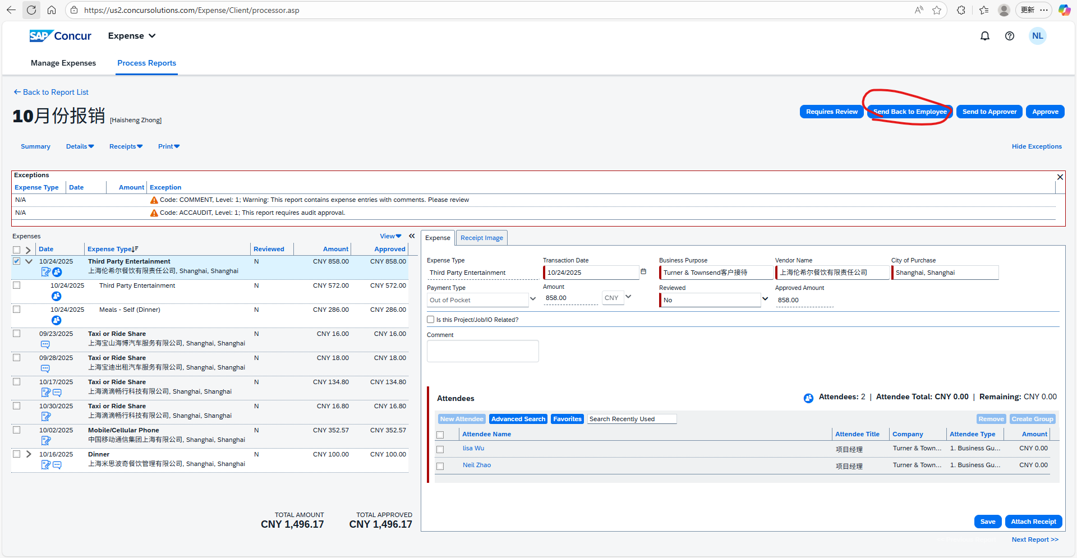

When the expense review is correct and the total amount exceeds the limit (the limit varies by region), click “Send to approver” at the top right. A window will appear; in “User-Added Approver,” select the required additional approver, enter comments, and click “Send to approver.”

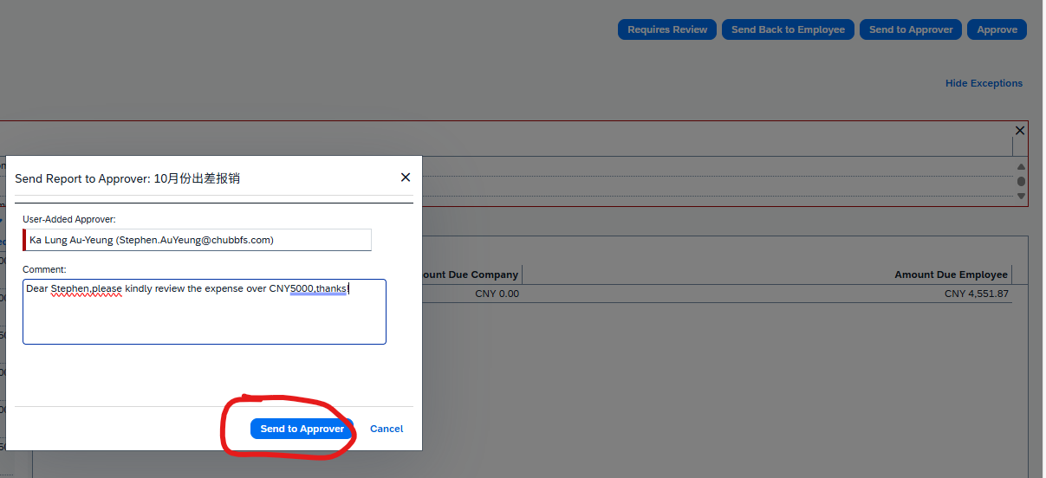

At this point, the status will change to “Submitted & Pending Approval – (Approver Name).” After approval, it will return to “Approved & in Accounting Review”.

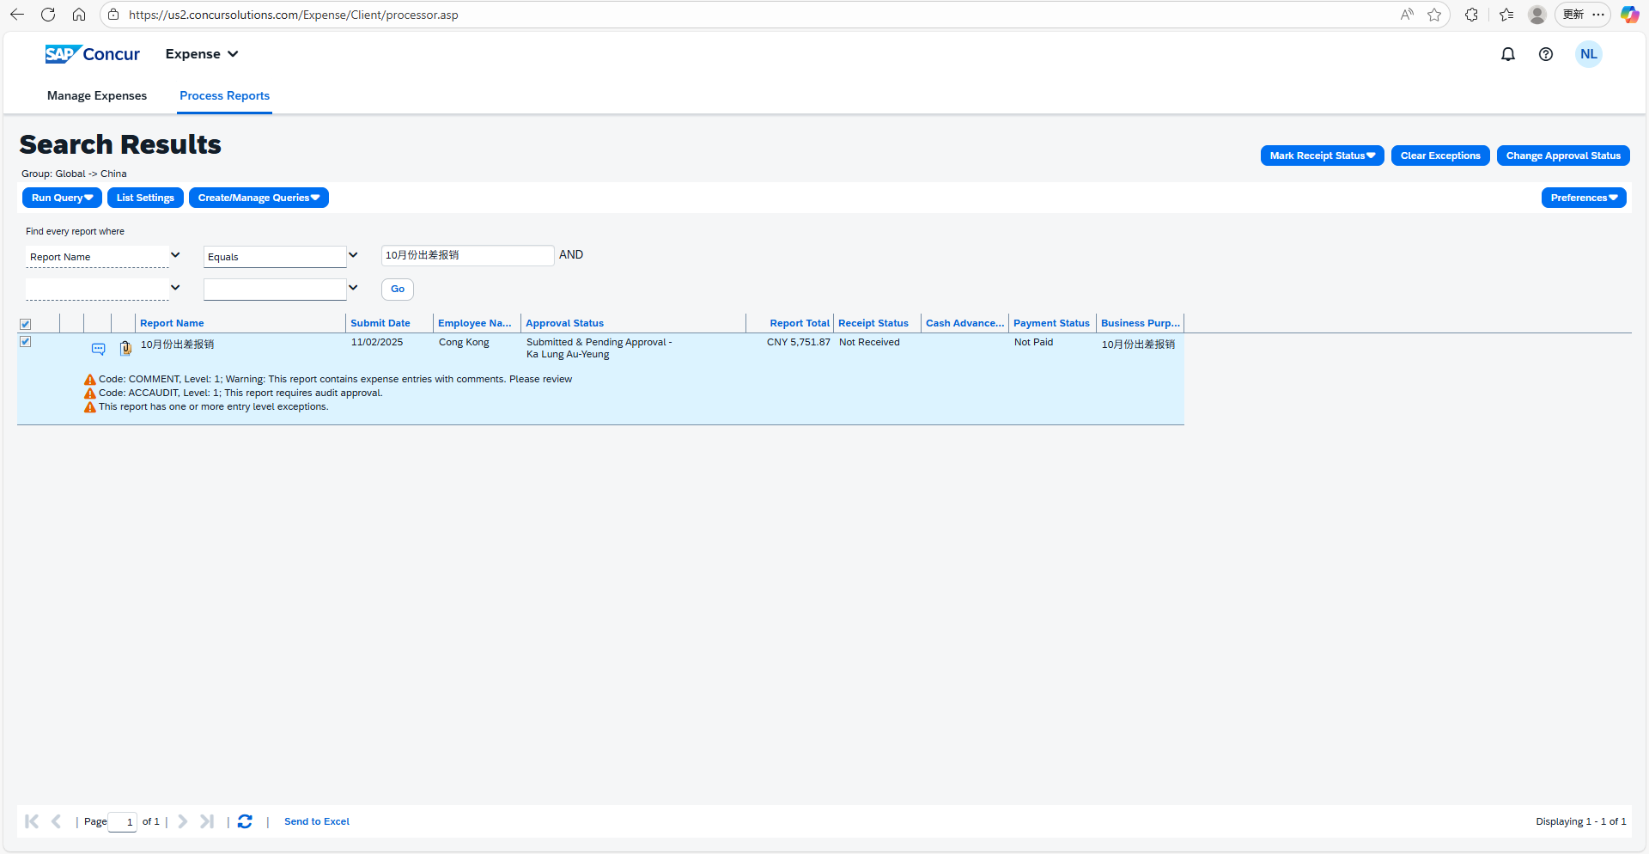

- Ensure supporting documents are attached: receipts and pre-approvals (e.g. travel, events and training) etc.
- Check compliance with relevant policies (e.g. Travel, Gift, Training etc.).

Accountant Review
- The processor forwards the expense report to the accountant for review and approval in Concur after completing the initial check in Step 1.
- The accountant completes the review in Concur and clicks "Approve"; the approval workflow will then return to the processor for final approval.

When the expense review is correct, click “Send to approver” at the top right, and in “User-Added Approver,” select the accountant for each region to perform the review. After the accountant review, click “Approve”.

Processor Action
- Processor performs final approval in Concur for the reports reviewed by the accountant.
When the expense review is correct and accountant approval has been obtained, click “Approve”.

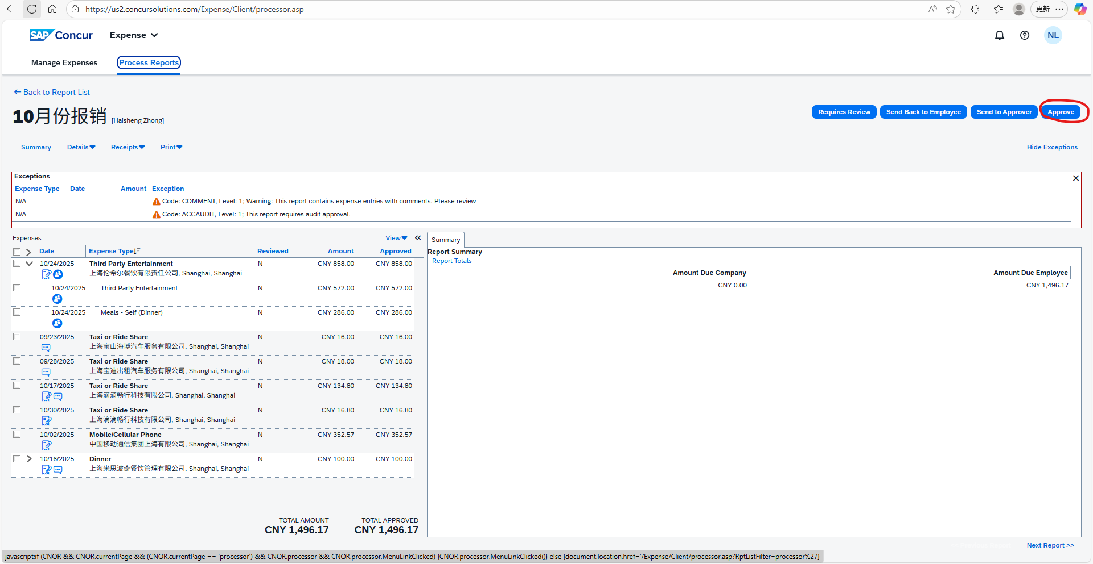

After clicking “Approve,” the expense claim’s “Approval Status” will change to “Approved”.

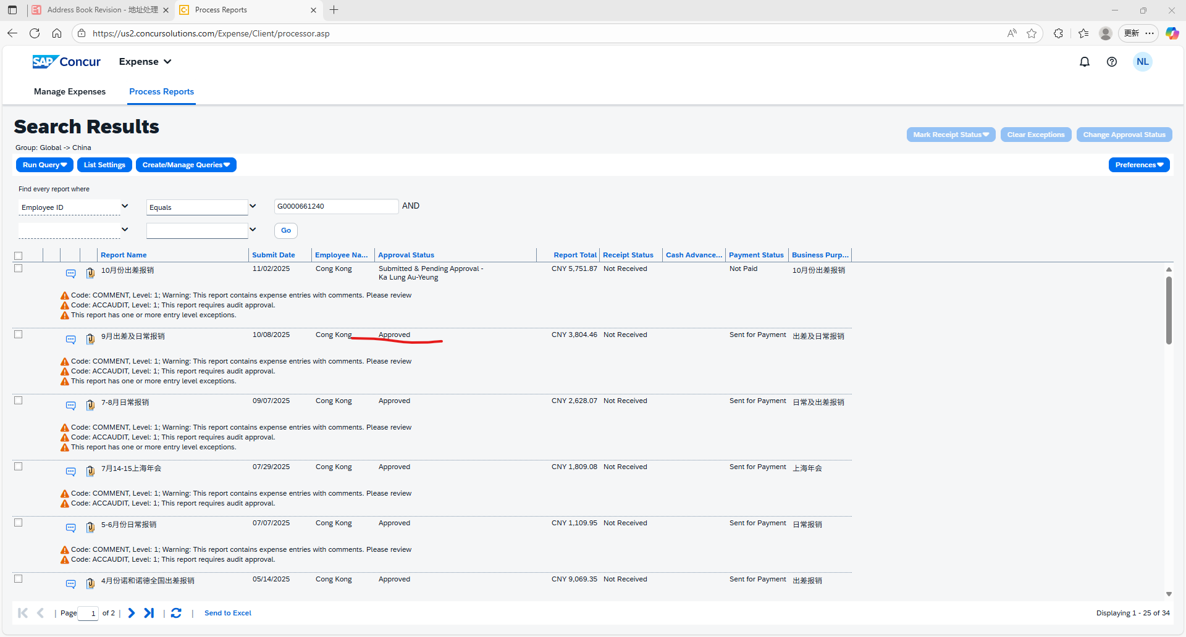

Payment list Generation (14th of each month)
- System automatically generates GV files and SAE files for approved reports and save the files at designated location (\\cnhkgfnp01\SAE\Concur_Rev\GlobalHR\Chubb).
All expense claims with an “Approval Status” of “Approved” for the current month will generate SAE reports in text format at the following location: \\chkkld03\NewSAE_REV\ChubbCN

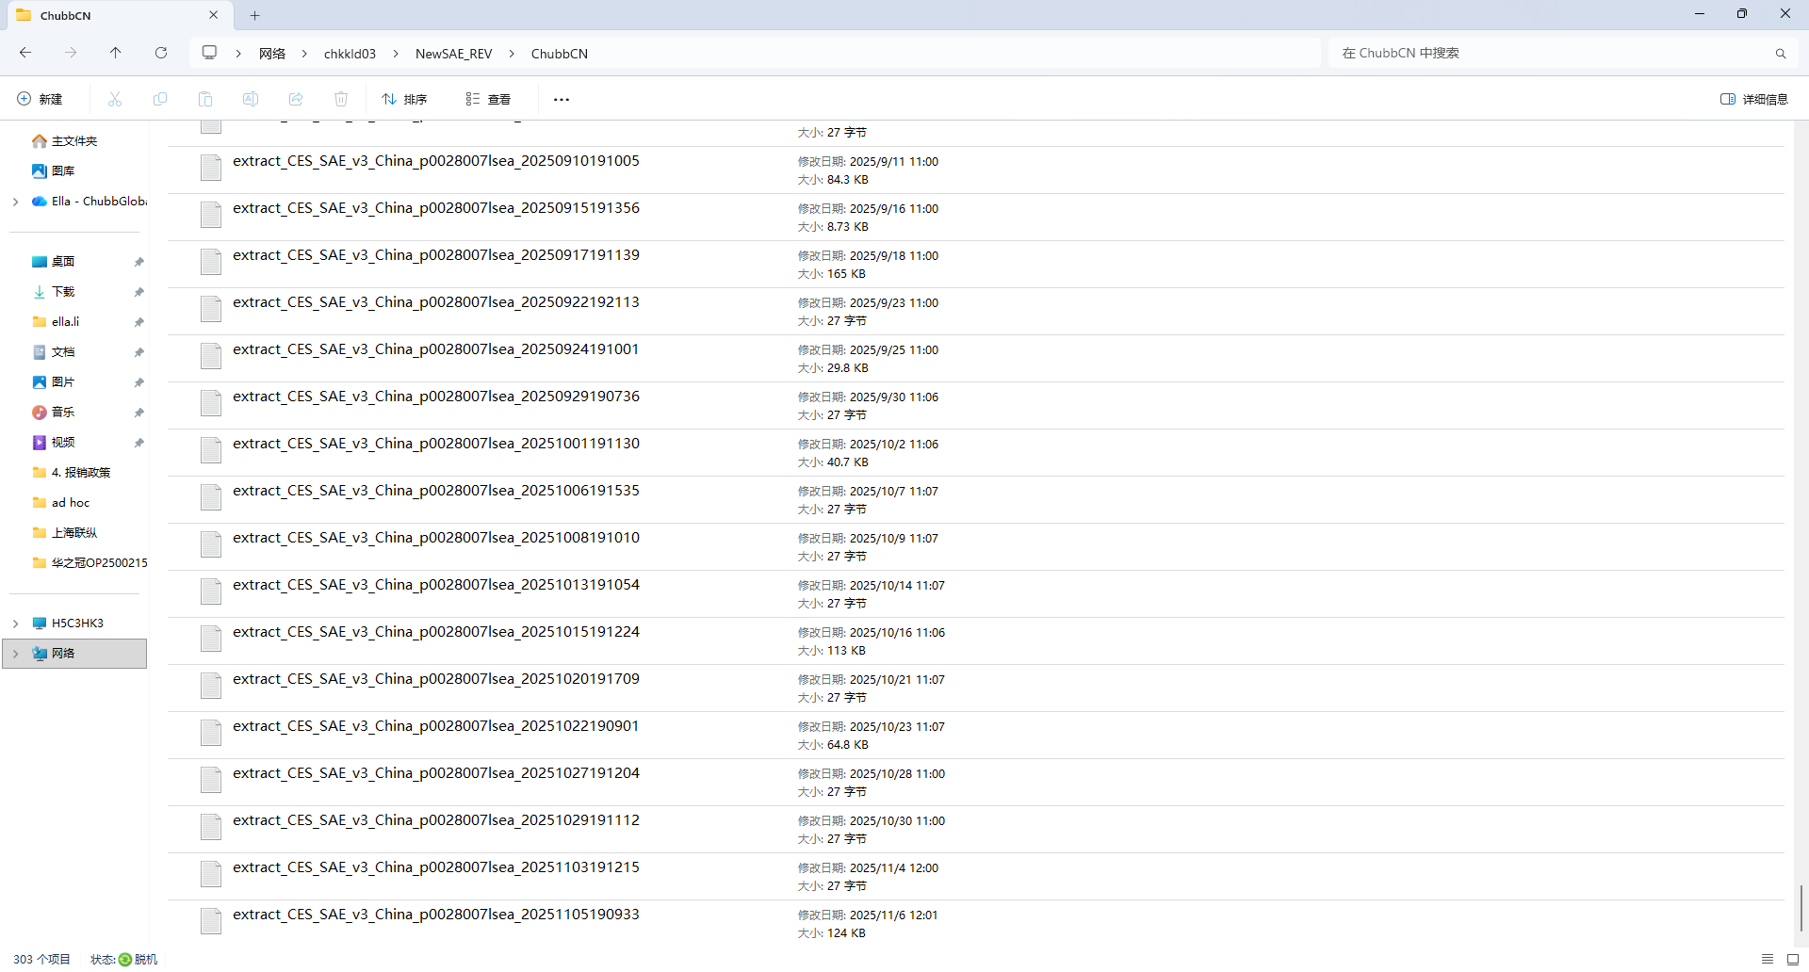

Open it in Excel as shown in the figure.

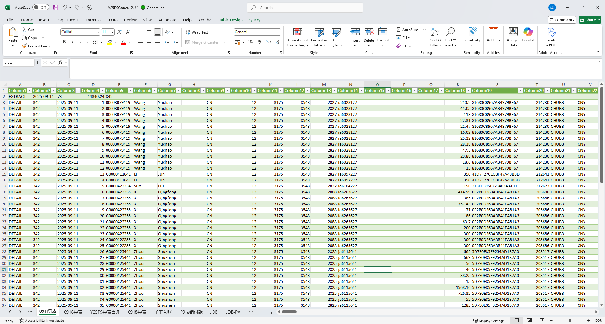

- HK/China: Export approved transactions from Concur to Excel and prepare a payment list.
- Macau: Manually prepare the payment list due to the limited number of employee reimbursements (<10 monthly)

Payment List Validation
- Validate that GV files/Payment List match approved expense reports.
- Pass the Summary Report with supporting documents for review and approval.

GV File Upload - For HK only; China/Macau skip this step and proceed to next step
- Upload validated GV files to the prescribed folder for payroll processing (\\CHKKLD03\GlobalHR\Concur\To_GV\Chubb).

Email Notification
- HK/Macau: Send Payment List to payroll team for cross-checking amounts, as employee reimbursements are paid via payroll.
- China: Extract the invoice-free meal allowance for engineers and send them to HR for payment via payroll. Other employee reimbursements are paid to employees’ bank accounts via bank transfer.
- Copy specified recipients for information.

Journal Entry Generation (15th of each month)
- Generate monthly JDE journal entries and save files at the prescribed location (\\cnhkgfnp01\SAE\Concur_Rev\JDE)

Upload to JDE
- Upload prepared journal entries into the JDE system to finalize records.

Simplified Workflow Table
Step | Action Summary | Key Output
Expense Check | Verify details & documents | Validated Expenses Report
Accountant Review | Review by accountant | Approved Expenses Report
Processor Action | Approve Expenses Reports | Ready for Export
Report Generation | Generate GV files / payment list and Export data and prepare summary | GV File & Summary Report(HK);  Payment List (China/Macau)
Report Validation | Validate GV files / payment list | Validated GV File (HK);  Validated Payment List (Macau/China)
GV File Upload (HK only) | Upload GV file to folder | Filed GV file
Email Notification | Notify payroll team | Sent Final Payment List
Journal Entry Generation | Generate JDE journal entries | JDE Journal
Upload to JDE | Post entries to JDE system | Finalized Transactions

Concur Processor SOP
- Training video link: https://learning.sap.com/browse/products/concur-expense?access=free&page=1&product=concur-expense

Appendix A - Flowchart

