China Capability Centre
(“CCC”)
Project: Automated eForm and Approval Workflow System
MCHM Finance
Business Requirements Document (BRD) and Fit Gap Analysis
April 08, 2025

Contents
2 Introduction 3
3 Business Requirements Document (BRD) 3
3.1 Business Objectives 3
3.2 Project Scope 3
3.3 Stakeholder Analysis 3
3.4 Functional Requirements 3
3.5 Non-Functional Requirements 4
3.6 Potential Risks and Mitigation Strategies 4
3.6.1 Potential Risks 4
3.7 Assumptions and Constraints 4
3.8 Approval and Sign-off 5
4 Fit Gap Analysis 6
4.1 Define Objectives 6
4.2 Current State 6
4.3 Future State Requirements 6
4.4 Gap Identification 6
4.5 Action Plan 7
5 Appendix One 8
6 Appendix Two 9
7 Appendix Three 10

Introduction
This project aims to implement an automated eForm and approval workflow system to streamline processes, enhance collections efficiency, reduce overdue balances, shorten Days Sales Outstanding (DSO), and expedite payment allocations. Additionally, the project seeks to digitize the credit notes process and incorporate predefined reason codes for user selection, with reporting capabilities to align with other Chubb entities and measure performance.

Standardizing the process for issuing credit notes to customers in alignment with MCHM will accelerate revenue recognition and improve customer satisfaction. This directly impacts key performance indicators (KPIs) related to customer retention and turnover rates. [Appendix One]

Business Requirements Document (BRD)

Business Objectives
- Improve collections efficiency
- Reduce overdue balances
- Shorten DSO
- Expedite payment allocations
- Digitize the credit notes process
- Include predefined reason codes for user selection
- Enable reporting on issued credit notes by predefined reason codes
- Ensure IFRS Compliance: Revenue recognition, financial statements, trade receivables, and payables adjustments.

Project Scope
Includes:
- eForm creation,
- Approval workflow,
- Digital signatures,
- Real-time tracking,
- Integration with payment allocation systems,
- Predefined reason codes for credit notes, and
- Reporting capabilities.
Excludes integration with external systems not related to payment allocations.

Stakeholder Analysis
- IT team
- Billing team (BU administration team)
- Finance department
- Credit Control and Collections team

Functional Requirements
- Automated form creation
- Prompt warning message if a credit was generated before
- Digital signatures and approval workflow
- Real-time tracking and notifications
- Integration with billing/payment allocation systems (Optional)
- Predefined reason codes for credit notes
- Reporting on issued credit notes by predefined reason codes
- Credit Note Adjustments: Reflect accurate revenue recognition, proper documentation in financial statements, and correct adjustments to trade receivables and payables.
- Allow the requestor inputs the following data:
- Invoice number
- Credit Amount (logical check: Credit amount cannot exceed invoice amount)* Do we allow partial credit amount?
- Revised re-issue invoice amount
- Calculate the difference between credit amount and re-issue invoice amount.

Non-Functional Requirements
- System uptime of 99.9%
- Data encryption
- User-friendly interface
- Scalability to handle increasing volume of credit notes

Potential Risks and Mitigation Strategies

Potential Risks
Item | Title | Description
1. | Scope Creep | Uncontrolled changes or continuous growth in a project's scope
2. | Budget Overruns | Exceeding the allocated budget due to unforeseen expenses
3. | Resource Conflicts | Competing demands for limited resources.
4. | Technical Failures | Issues with software or hardware that disrupt project progress.
6. | Stakeholder Misalignment | Differences in expectations or priorities among stakeholders
7. | Operational Changes | Changes in business operations that impact the project.
8. | Low User Adoption | Resistance from users to adopt the new system.
9. | Time Crunch | Tight deadlines leading to rushed work and potential errors.
10. | Regulatory Compliance | Failure to meet industry regulations and standards.

Assumptions and Constraints
Assumptions:
  - Availability of necessary hardware and software
  - Support from stakeholders
Constraints:
  - Budget limitations
  - Project timeline

Approval and Sign-off
- Sign-off: [Stakeholder names and signatures]

Fit Gap Analysis

Define Objectives
Automate eForm creation and approval workflow to improve collections efficiency, reduce overdue balances, shorten DSO, and expedite payment allocations. Aim to achieve no outstanding invoices over 90 days, no aged credit notes over 60 days, and no unallocated cash receipts over five days. Digitize the credit notes process and include predefined reason codes for user selection.

Current State
Manual processes for credit notes (data entry across platforms, multiple approvals) lead to inefficiencies and higher error rates. The count of credit notes issued each month shows a moderate upward trend from 162 to an average of 178 per month. Process delays due to manual approval processes hampered by work duties, leading to delayed resolutions and compounded workloads. No existing system in place.
Current state process flow - Appendix Two

Future State Requirements
Future state process flow – Appendix Three
- Automated eForm creation
- Digital signatures
- Real-time tracking and notifications
- Integration with payment allocation systems
- Predefined credit reason codes for user selection
- Reporting capability on issued credit notes by predefined reason codes
- Discussion: Should Credit notes will be used to apply for Admin Fee and Levy deduction.
- IFRS Compliance:
- Revenue Recognition (IFRS 15): Adjustments made via credit notes should reflect accurate revenue recognition. If a credit note is issued due to returned goods or discounts, it should be accounted for in the period in which the transaction occurred.
- Financial Statements: Credit notes should be properly documented and reflected in the financial statements to ensure transparency and accuracy.
- Trade Receivables and Payables: Adjustments to trade receivables and payables should be made to reflect the correct amounts after issuing credit notes.

Gap Identification
- Lack of automation
- No digital signature capability
- Manual tracking and approval processes
- Increasing volume of credit notes without efficient handling
- No predefined reason codes for credit notes
- No reporting capability on credit notes by reason codes

Action Plan
- Implement eForm software
- Integrate digital signature tools
- Develop a real-time tracking system
- Streamline approval workflows
- Add predefined reason codes for credit notes
- Develop reporting tools to align with other Chubb entities and measure performance

Appendix One
Benchmark KPI Targets (CRITICAL CASH CYCLE DRIVERS)
Critical Cash Cycle Driver | KPI Target / Recommendations
Unallocated Cash (incl. Credit Notes) | - Reduce Unallocated Cash by 40% over two quarters in high-impact regions (France, Australia, UKI).  - Ensure value of unallocated cash does not exceed two days of average receipts.  - Implement same-day resolution policies for high-value receipts.  - Short-term KPI: Resolve all unallocated cash within 30 days.  - Long-term KPI: Align unallocated cash resolution to a 14-day turnaround.
Dispute Resolution | - Reduce total dispute volume by 25% within two quarters.  - Reduce disputed value to under $12.5M within two quarters.  - 80% of disputes resolved within 30 days.  - Reduce invoice error disputes by 30% within two quarters (First-Time-Right Billing Accuracy KPI).  - Assign regional dispute resolution teams for targeted intervention.

Appendix Two
Current Status of Credit Notes Process (SOX OTC06)
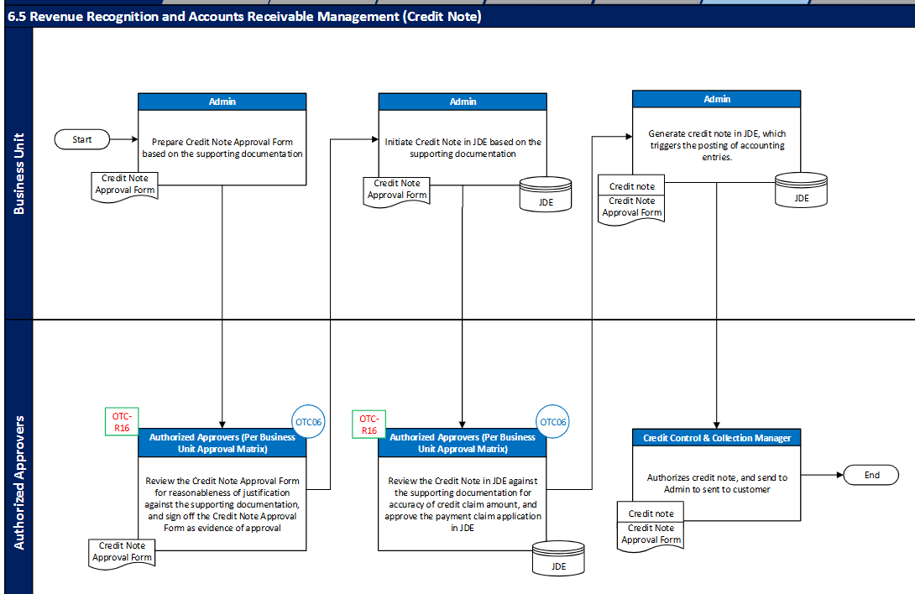

Appendix Three
Propose future Credit Notes process
