China Capability Centre
(“CCC”)
Project: Sub-Contractor Work Completion Certificate Workflow System
MCHKM Finance
Business Requirements Document (BRD) and Fit Gap Analysis
May 21, 2025

Contents
2 Introduction 4
3 Benefits 4
4 Business Requirements Document (BRD) 4
4.1 Business Objectives 4
4.2 Project Scope 4
4.3 Stakeholder Analysis 4
4.4 Functional Requirements for JDE System Enhancement 4
4.5 Non-Functional Requirements 6
4.6 Potential Risks and Mitigation Strategies 6
4.7 Assumptions and Constraints 7
4.8 Approval and Sign-off 7
5 Fit Gap Analysis 8
5.1 Define Objectives 8
5.2 Current State 8
5.3 Future State Requirements 8
5.4 Gap Identification 8
5.5 Action Plan 8
5.6 Approval Workflows Design 8
6 Appendix One - Benchmark KPI Targets 9
7 Appendix Two - Current State Process Flow 10
8 Appendix Three - Future State Business Process Flow 11
9 Appendix Four – Future State System Process Flow 12
10 Appendix Five – Approval Matrix 13

Introduction
The purpose of this document is to outline the business requirements and fit gap analysis for the implementation of an automated approval workflow system for sub-contractor payment applications. This initiative aims to streamline the approval process, enhance operational efficiency, reduce processing time, and ensure compliance with financial regulations. The proposed system will digitize the entire workflow, from application submission to final approval, and provide real-time tracking and reporting capabilities.

Benefits
- Develop a streamlined process for managing supplier invoices, including issue resolution, approval, reducing delays and errors.
- Reduces paper usage and speeds up invoice processing.
- Standardize the process across MCHKM.
- Improve the tracking of supplier transactions through an online approval system.
- Paperless process, providing easier access and management.

Business Requirements Document (BRD)

Business Objectives
- Streamline the sub-contractor payment approval process.
- Reduce processing time and minimize manual errors from Business operational team to Finance team.
- Ensure compliance with financial regulations.
- Provide real-time tracking and notifications.
- Enhance transparency and accountability

Project Scope
Includes:
- Automated application submission.
- Approval workflow including UBR
- Real-time tracking and notifications.
- Integration with financial systems.
- Reporting capabilities.

Excludes integration with external systems not related to payment allocations.

Stakeholder Analysis
- IT team: Responsible for system implementation and maintenance
- Billing team (BU administration team): The owner of the existing process.
- Procurement Team: Communication plan to impacted contractors
- Finance department – Accounts payable

Functional Requirements for JDE System Enhancement
The following functional requirements are proposed for the implementation of a new automated function in the existing JD Edwards (JDE) system. This initiative aims to streamline and improve the current manual processes related to application submission, approval, invoice matching, and certification within the MCHKM.

Application Payment Request submission and Approval
- Pregenerated List of Open OS (One OS matches One Payment Request)
The system displays a filtered list of open OS for authorized users, allowing them to enter the amount of work received from contractors as per the services rendered.
- Automated Application Submission:
The system shall enable electronic submission of applications, eliminating the need for manual data entry.
- Digital Signatures:
All approval processes shall support secure digital signatures to ensure integrity and authorization of transactions.

Tracking, Notification, and Integration
- Real-Time Tracking & Notifications:
Users shall be able to monitor the status of submissions and approvals in real-time. Automated notifications shall be triggered at key process milestones.

- Financial Systems Integration:
The new function shall seamlessly integrate with existing financial systems to ensure consistent and accurate financial data flow.

Reporting Requirements
- Approval Progress Reporting:
The system shall provide reports on application and invoice approval statuses, as well as processing times, for management oversight.
- Rejection Analysis Reporting:
Detailed reports on all rejected invoices, including explicit reasons for rejection, shall be available.
- Certified Payment Requests Reporting:
Reporting capabilities shall include identification of matched and certified payment requests.

User Interface
- User-Friendly Design:
The system interface shall be intuitive and straightforward, allowing internal users to easily identify open Committed OS items.

- Invoice-Payment Matching List:
Users shall be able to view a comprehensive list of incoming invoices that are matched to their respective payment requests.

Project and Service Confirmation
- Service Confirmation by Project Managers/Engineers:
The function shall allow designated personnel (Project Managers or Engineers) to confirm satisfactory completion of services, by either Purchase Order or Job/Project.
- Input of Key Data Elements:
The system shall support input of critical confirmation data including satisfied amount, quantity, and unit price. Ideally, calculate the projected job revenue.

System Functionality for Invoice Processing
- Payment Request Certification (One Payment Request Certificate matches One Invoice):
The system shall aggregate approved payment certifications (OS) by sub-contractors and route them through the relevant Delegation of Authority (DOA) for payment request form generation.
- Automated Invoice-Payment Matching:
Incoming invoices shall be automatically matched with approved payment requests.
- Invoice Date Validation:
Invoices with dates prior to the Purchase Order date shall be automatically rejected.
- Automated Invoice Rejection & Communication:
Unmatched invoices, or those without validated payment requests, shall be automatically rejected, with reasons communicated clearly to the sub-contractor.
- Compliance Monitoring:
The system shall ensure that submitted invoices do not exceed the Project Manager-certified amounts, with a tolerance threshold not exceeding 1% or $1, whichever is lower.
- Credit Memo Control:
Only full credit memos shall be accepted by the system; partial credit memos will not be permitted.
- Batch Printing Functionality:
Users shall have the capability to print all outstanding invoices and associated attachments via a "Print All" feature.

Non-Functional Requirements
- System uptime of 99.9%
- Data encryption
- User-friendly interface
- Setup a standardized template.

Potential Risks and Mitigation Strategies

Potential Risks
Item | Title | Description
1. | Scope Creep | Uncontrolled changes or continuous growth in a project's scope
2. | Budget Overruns | Exceeding the allocated budget due to unforeseen expenses
3. | Resource Conflicts | Competing demands for limited resources.
4. | Technical Failures | Issues with software or hardware that disrupt project progress.
6. | Stakeholder Misalignment | Differences in expectations or priorities among stakeholders
7. | Operational Changes | Changes in business operations that impact the project.
8. | Low User Adoption | Resistance from users to adopt the new system.
9. | Time Crunch | Tight deadlines leading to rushed work and potential errors.
10. | Regulatory Compliance | Failure to meet industry regulations and standards.
11. | Transition period | Mismatch invoice with certified OS.
12. | Certification of Under Billing Jobs | Unable to certify OS when the job is on hold. (UBR D1/D2 hold)

Mitigation Strategies
- Define clear project scope and objectives.
- Monitor budget and expenses regularly.
- Allocate resources effectively.
- Conduct regular technical reviews.
- Align stakeholder expectations through regular communication.
- Provide user training and support.
- Set realistic timelines and milestones.
- Ensure compliance through regular audits.

Assumptions and Constraints
Assumptions:
  - Availability of necessary hardware and software
  - Support from stakeholders
  - Operation team agreed with the new process
Constraints:
  - Budget limitations
  - Project timeline

Approval and Sign-off
- Sign-off: [Stakeholder names and signatures]

Fit Gap Analysis

Define Objectives
Automate the sub-contractor payment approval process to improve efficiency, reduce processing time, and ensure compliance.

Approval flow, reading the signature within DOA Matrix.

Aim to achieve no outstanding payment applications over 30 days and enhance transparency and accountability.

Current State
Currently, all invoices are manually signed by the project manager, and Finance AP checks invoices manually, tracking their status until month-end processing. This leads to inefficiencies and higher error rates. Delays due to manual approvals and lack of real-time tracking. No automated system exists in place.
Current State Process Flow - Appendix Two

Future State Requirements
Future state process flow – Appendix Three
- Pregenerate list of outstanding OS by Sub-contractor, by Job
- Automated payment request application submission.
- Digital signatures for approvals.
- Real-time tracking and notifications.
- Integration with financial systems.
- Matching requirement - One OS, One Payment Request, One Invoice

Gap Identification
- Lack of automation.
- Lack of control on certified services.
- No digital signature capability.
- Manual tracking and approval processes.
- No real-time tracking and notifications.
- No reporting capabilities

Action Plan
- Implement automated application submission software.
- Integrate digital signature tools.
- Develop a real-time tracking system.
- Streamline approval workflows.
- Develop reporting tools to measure performance.

Approval Workflows Design
The approval workflow will be designed in accordance with the Delegation of Authority (DOA) Matrix to ensure proper governance and accountability. The workflow will include the following steps:

Initial Review for Payment Request
- The Project Manager reviews the payment request application.
- The Project Manager can filter request payment by Project Manager, Project, and Sub-contractors.
- If the application is valid, the Project Manager approves it and adds the UBR hold code.

Approval Matrix
- The payment request process follows the DOA Matrix for further approvals.
- Each level of approval is recorded with digital signatures.
- Notifications are sent to the relevant approvers at each stage.

Submission:
- Sub-contractor submits the payment request through the automated system.
- The system automatically matches the PO# with the submitted invoice.
- The system checks if the invoice date is prior to the Purchase Order date and rejects if necessary.
- The system ensures the invoice amount does not exceed the Project Manager's certified amount.

Final Approval
- The listed team members receive the approved payment request notification report.
- The system automatically generates a Payment Voucher (PV) prior to Hold (H) status based on the Payment Request information.
- The Finance AP team changes the status from pre-Hold (H) to Hold (H) status, then Approved (A) upon final approval.

How to manage EC, Contra Charge and Retention
Engineer or project manager inputs the Contra Charge, EC percentage and retention amount when raising the Payment Request
EC Percentage as following:
ES – 1%
FS – 1.3%
ACSL - 1.27%

Appendix One - Benchmark KPI Targets
Benchmark KPI Targets (CRITICAL CASH CYCLE DRIVERS)
TBC

Appendix Two - Current State Process Flow
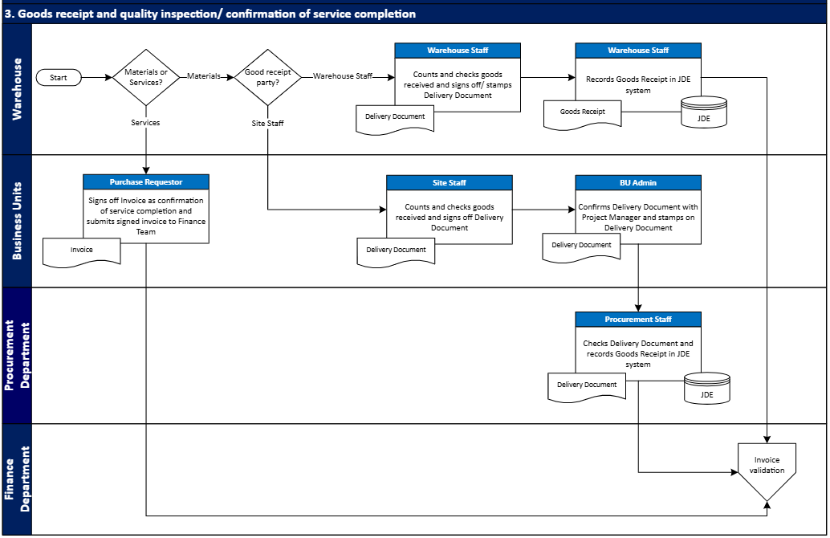

Appendix Three - Future State Business Process Flow
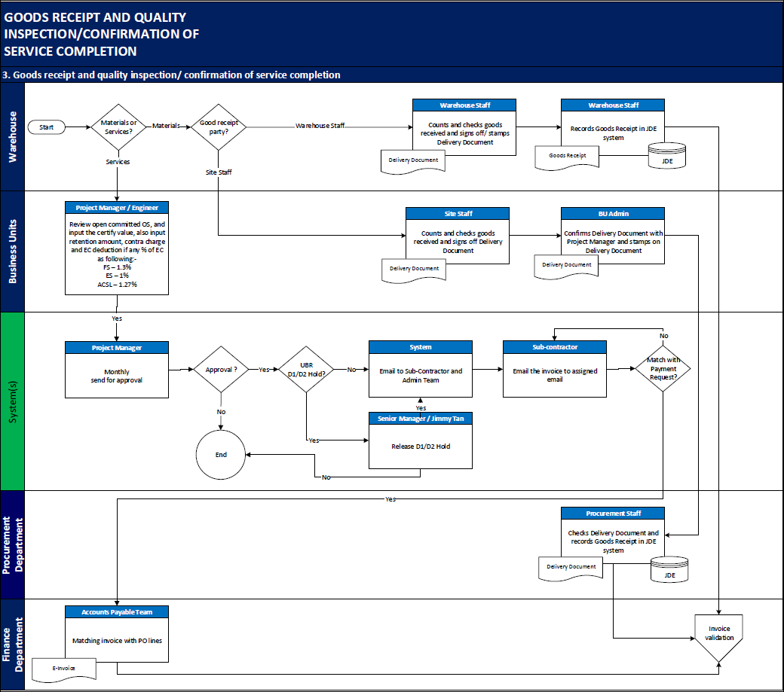

Appendix Four – Future State System Process Flow
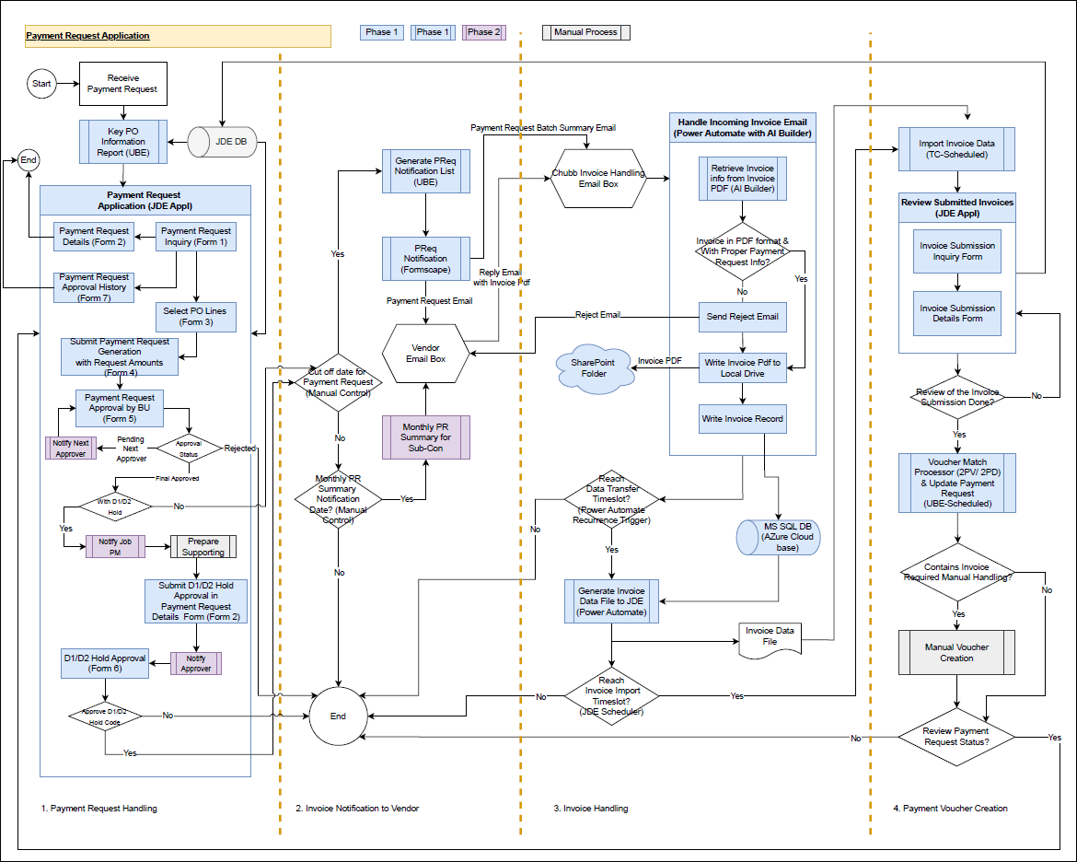

Appendix Five – Approval Matrix
OC-Sub-contractor (MCHKM)
