Account Payable
Invoice Match Procedures

Step 1. Invoice Input

1.1 Voucher matched with goods receipts – 3 way matching
From the Operation under Account payable module, choose Match Voucher with goods received.
  - Click to add a voucher
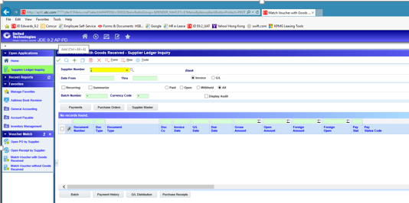

  - On Voucher Match, complete the following fields to enter record information:
- Supplier
- Invoice Number.
- Invoice Date
- G/L Date
- Co.
- Order Number (Optional)
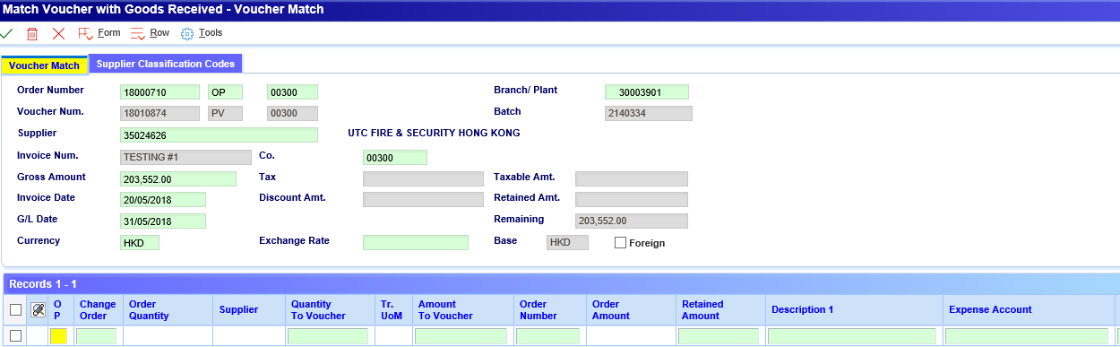
  - Choose Receipts To Match from the Form menu.
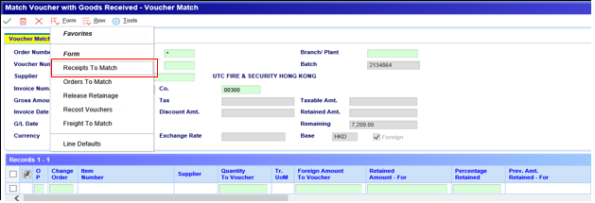
  - On Select Receipts to Match, completed optional fields (e.g. PO No.) and click
  - Choose the receipt records that correspond to the invoice and click .
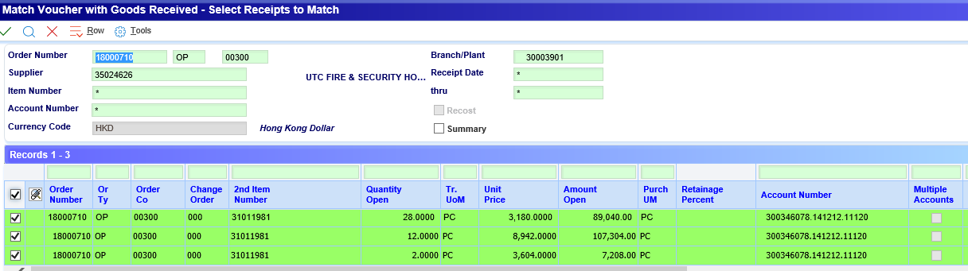
The system returns the lines which selected to the Voucher Match form.
  - Complete the following optional fields for receipt records to reflect the invoice, as necessary:
- Amount To Voucher
- Quantity To Voucher
  - Click to save the voucher

1.2 Voucher without goods received – 2- way matching
From the Operation under Account payable module, choose Match Voucher without goods received.
- Click to add a voucher
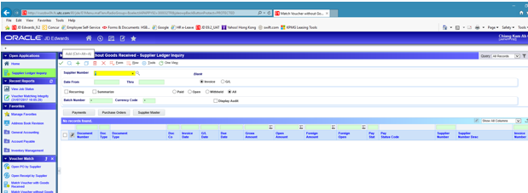
On Voucher Match, complete the following fields to enter record information:
- Supplier
- Invoice Number
- Gross Amount.
- Invoice Date
- G/L Date
- Order Number (Optional)
- Choose Orders To Match from the Form menu.
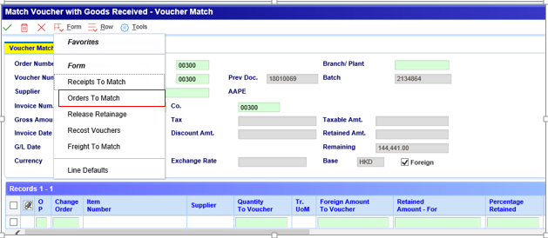
- On Select Orders To Match, click .
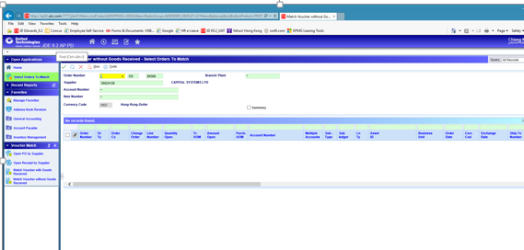
- Choose the order detail lines and click .
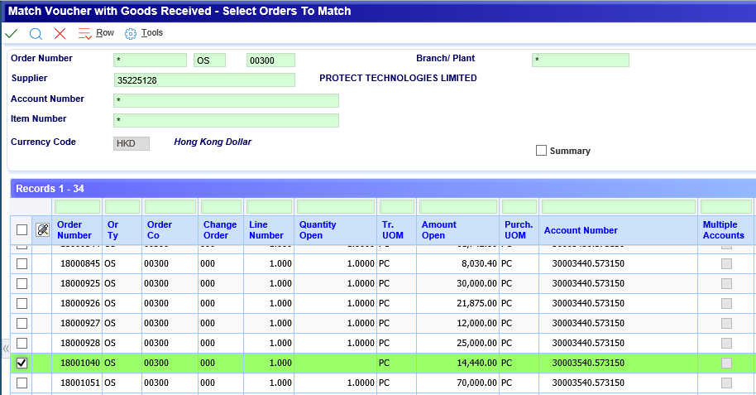
- The system returns the lines which selected to the Voucher Match form.
- On Voucher Match, change the following field for order detail lines, as necessary: Retained Amount
- Click to save the voucher.

1.3 AP Journal voucher printing
From AP Detail reports of AP Report menu, Choose AP voucher journal by batch
- In data selection, enter the batch number and Click to proceed
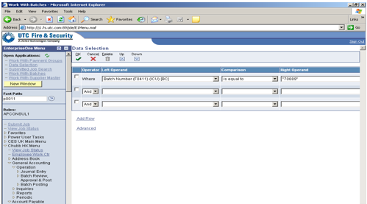
- In processing option, enter 1 to print account numbers in the format BU, object, subsidiary
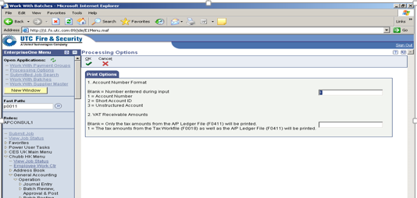
- In printer selection, Click to final submit the job. The pdf output file is shown below.
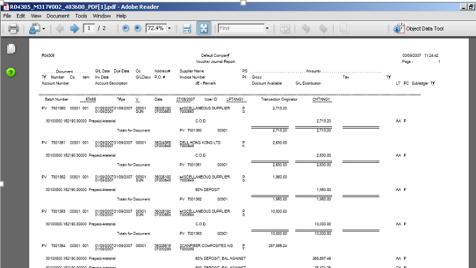

1.4 Attach invoice and Supporting to the Voucher
    - Click invoice and select attachments
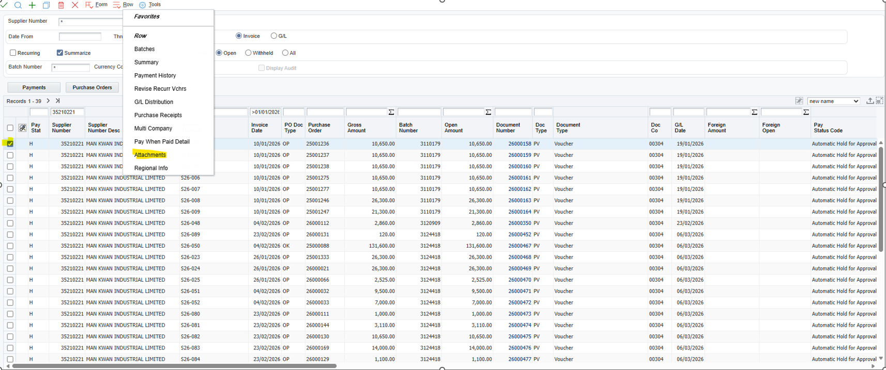
    - Click File
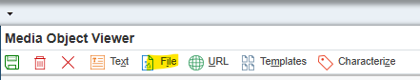

    - Click select local file and choose file
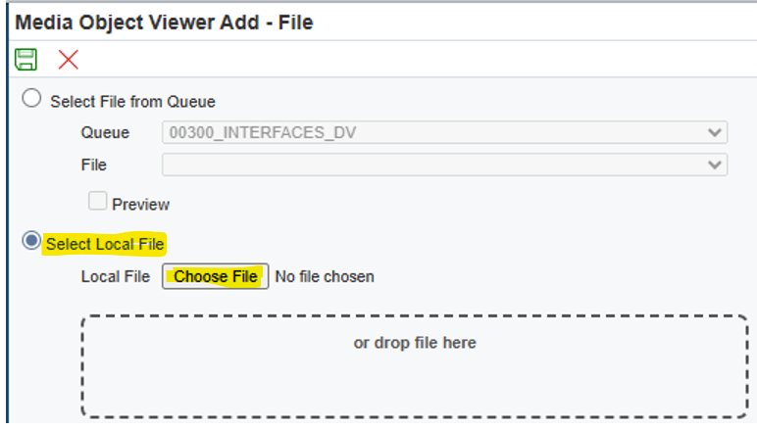
- After choose file, click .
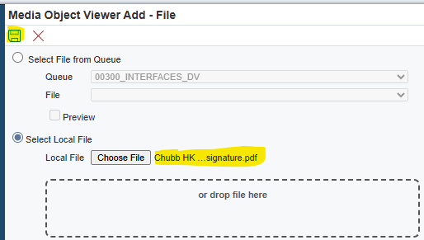
- Click to finish
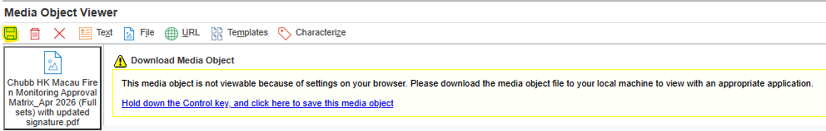

- The invoice and supporting can be found in

Order type | Last Status | Next Status | Can be Voucher Matched
OK, ON, OP | 290 | 400 | No. Waiting for goods receipt.
OK, ON, OP | 400 | 400 | Yes by [Form – Receipts to Match]. This is partial receipts for OK and ON, or partial receipts and issues for OP
OK, ON, OP | 400 | 999 | Yes, by [Form – Receipts to Match], if this is only the full receipts for OK and ON, or full receipts and issues for OP.
OS, OT | 290 | 400 | Yes
OS | 400 | 400 | Yes by [Form – Order to Match]. This is partial voucher matched.
OS | 400 | 999 | No. Full voucher match has done

