1. New Customer Account Creation
Current Process Flow
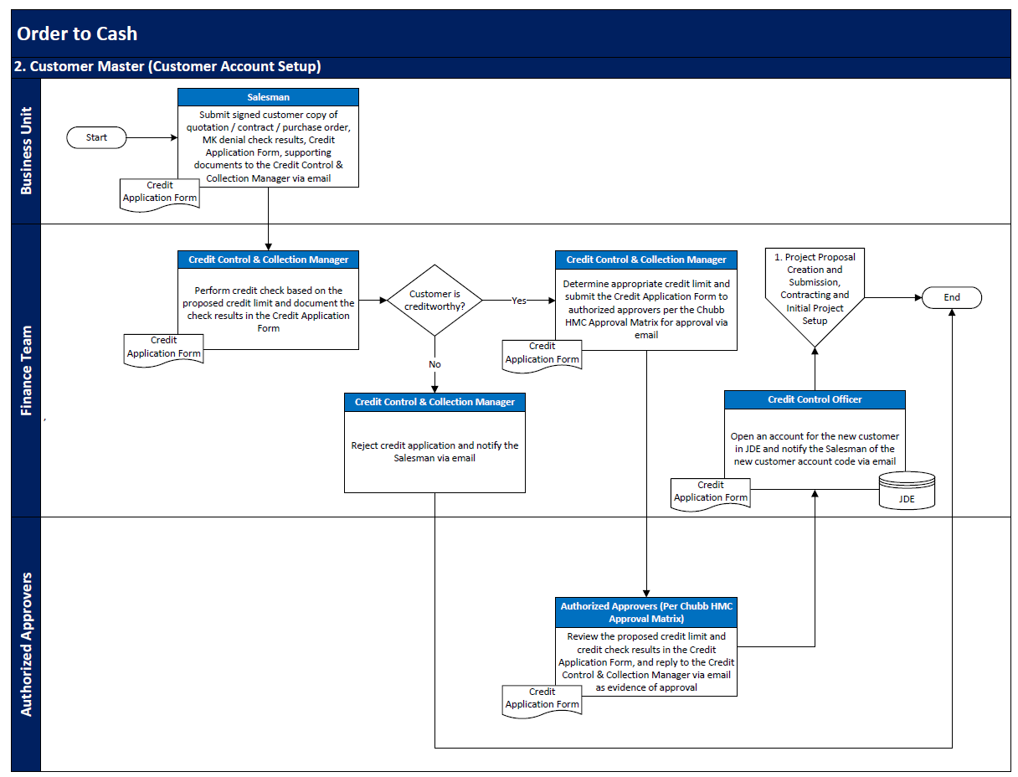

Pain Point: After receiving the application from the BU Admin, the Credit Control Manager may take 2-3 days to complete the review based on daily work prioritization. If the application is approved, the Credit Control Officer will proceed with the data input to JDE (0.5-1 day of lead time) and inform the BU Admin of the Account Number.
Improvement Plan: BU submits the application to a "Platform" and sends a notification email to the Credit Control Officer. The Credit Control Officer reviews the submitted documents. If no issues are found with the submitted documents and application, the Credit Control Officer takes further action to submit the application to the Credit Control Manager through the "Platform" (Target lead time: 1 day). Once the Credit Control Manager receives the notification from the "Platform," they will grant the payment term and credit limit and approve it in the "Platform" (Target lead time: 1 day). After this process, the "Platform" or some tools will automatically input the data into JDE.
Frequency: Daily
Benefit of the new process:
1. Lead time will reduce to 2 days from 4 days
2. Improve the data accuracy
3. Transparent of the application status
Process owner
CheukWing Fan and Wendy Shing

2. Credit Hold review
Current Process
Pain Point: For each rejected case, Credit Control Manager will send a email to the requester and the collector for the reject reason and insert the outstanding list in the manually.
Improvement Plan: There has a Tool could help to send the outstanding list to the requester and collector and the credit control manager automatically.
Frequency: Daily
Benefit of the change:
To reduce the lead time of the rejected cases and improve the response rate.
Process owner
CheukWing Fan

3. Format of the Statement of Account
Existing Format
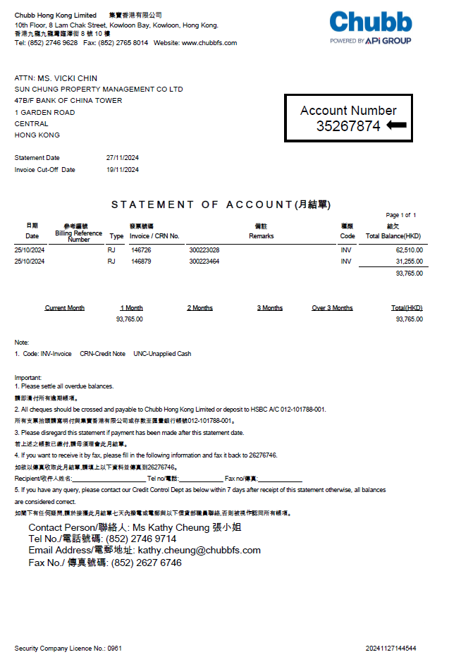

Pain Point: The statement does not display useful information such as the PO number, quotation, and site address location. Some clients request this information on the statement; otherwise, they will ignore it. Currently, the collector manually writes the requested information on the statement before sending it out.
Improve plan:
To reformatting the statement of account
Frequency: Twice a month
Benefit of the change:
To improve the payment lead time from the client
To reduce the lead time of the manual work from the collector
Process owner
CheukWing Fan and Celia Lee

Others pain points
Credit Note?
Change the envelope cutting for ACS – The envelope format is not suitable for the folding machine. The collector need to manually put the statement of account and reminder in the envelope.
Cheque Register - AI ? Scan the cheque and extract the cheque detail (e.g. bank name, cheque number, payment amount and payer company name) to the excel file ?
JDE Settlement ?

